Group Project   
Subject: Basic Cross-Platform Application Programming With .NET

*<Digital Distribution Store - eStore>*

***<Status: In progress>***

**Prepared by <TAT>**

***<Nguyễn Thành Trung>***

***<Trịnh Nam Anh>***

***<Lê Trần Mỹ Đan >***

**November, 2021**

Table of Contents

1. Case Study 1

1.1 Purpose and Description 1

1.2 Objectives of the Study 1

1.3 Methodology 2

1.4 Requirement Analysis 2

2. Database Design 2

3. System Architecture 3

3.1 Conceptual Diagram 3

3.2 Technical Information 4

4. Implementation 5

4.1 Member Views 5

4.2 Admin Views 9

**Revision History**

|  |  |  |  |
| --- | --- | --- | --- |
| **Name** | **Date** | **Reason For Changes** | **Version** |
| *Dan Le* | *30 September 2021* | *Initial draft* | *1.0 draft 1* |
| *Dan Le* | *3 October 2021* | *Add Database Design* | *1.1 draft 1* |
| *Dan Le* | *12 October 2021* | *Modify Database + Add Architecture* | *2.0 draft 2* |
| *Dan Le* | *5 November 2021* | *Add Implementation* | *2.1 clean* |

# Case Study

## Purpose and Description

In order to improve the overall processes of the selling and recording activities, the study had provided the clients a content management system with specific functionalities that coincided with the selling service. A content management system is a set of tools that provides an organization with a way to manage digital information on an application creating and maintaining content without prior knowledge of web programming or markup languages. The developed system also includes a Member/Staff and Product Information Registry, and an Inventory Management System. A registry is an organized system that collects uniform data to be presented, accounted and extracted for the business.

The developed system unified the data stored within one database to significantly increase organizational output and decreased the time consumed compared to the former system utilized.

## Objectives of the Study

* + 1. *General Objective*

The researchers aimed to develop a Content Management System as LOB (line-of-business) application for selling activities of a Digital Distribution Store.

* + 1. *Specific Objective*

The study specifically aims to specifically do the following:

1. A content management system that allowed users to create, update and delete contents.
2. An information registry where the information of products and staff members are entered and to be saved in a database.
3. An inventory management system that kept track of records regarding medical goods, its dissemination and records of consumption and in order to prevent unwanted spoiling.
4. A report generator that provides selling records, monthly/annual consumption report of productions, and the forecast of productions to be acquired the following year.
5. To implement the system in the store’s system.

## Methodology

Phase 1: **Planning**. The researchers gathered data through references which provided the problems, requirements, regarding the study.

Phase 2: **Requirement Analysis**. In this phase, all documentations and requirements has recorded along with the exchanges of correspondence between two parties. Supplementary to the information gathered during the Planning phase aided the researchers in determining the purpose and objectives of the study.

Phase 3: **Designing**. During this phase, the constraints regarding the proposed system has been determined and with that, the probable design of the interface, the database and the features had been incorporated in the system and was fully utilized in order to progress to the next phase.

Phase 4: **Building**. In this phase, the researchers had designed the database and the interface of the proposed system in relation to the requirements, recommendations and the concepts collected and generated from the previous phases. The Front-end is designed using C# and .NET 5, the back-end utilizes Microsoft SQL. All of these had been incorporated in a Content Management System of CMS.

The Software Development Process used by the researches is the Scrum. Scrum is defined as an iterative and incremental agile software development framework for managing product development.

## Requirement Analysis

* + 1. *Application Description*

eStore aims to be a data-driven platform centered on eStore chain of stores by providing the managers a foundation where all their patient data will be kept in a unified database for their sale and human resources management services. The store will be able to keep track of their staff member’s information and their inventory, the proper management of digital products and to be able to collect vital data that will be used in their research. With that, they will be able to provide their services in a much smoother manner.

* + 1. *User requirements*

The project is designed to have two direct users and those are Administrators and Staff Members. Each with their specific role in order for the application to properly function. The following are the types of users and their requirements.

Administrator/s

* Must be owned by a person of high organizational position.
* Must have an active email and mobile phone number.
* Has overall control over the system.
* Only entity able to create user accounts and sale contents (except orders).

Content Manager

* Must have an active email and mobile phone number.
* Only entity able to create/edit/delete orders.
  + 1. *Functional requirements*

Member

* Login
* Edit self’s information
* Order management:
  + Create order
  + Update/Insert order details
  + Checkout order + extract bill
  + View only created order (within that day)
* Product management:
  + View only list products
    - Sort by alphabet
    - Not view ID
    - Search by name – on text change
    - Sort by category – combo box

(select a field then view products with selected category)

* + Select a product to insert order detail into selected order
    - Make it auto either insert or update
* Log out

Admin:

* Login
* Member management:
  + Create member
  + Get list members
    - Sort by alphabet
    - Not view ID
    - Search by Name – on text change
  + Update member
  + Remove member
  + Ban member
* Category management:
  + Create category
    - Name must not duplicate
  + Get list category
    - Sort by alphabet
    - not view ID
    - Search by name – on text change
  + Update category
    - Name must not duplicate
  + Remove category
* Product management:
  + Create product
    - Name must not duplicate
  + Get list products
    - Sort by alphabet
    - not view ID
    - search by name – on text change
    - sort by category – combo box

(select a field then view products with selected category)

* + Update products
  + Remove product
* Order management
  + View only orders
    - Sort by day
    - Search by start day and end day (Must have 2 field for inputting 2 day)
  + View only order details (on-click the specified order)
* Log out
  + 1. *System requirements*

Desktop-only application (recommended):

* Monitor (Screen Resolution: ≥1366x768 pixels)
* Optical Mouse
* Full-width Keyboard

# Database Design

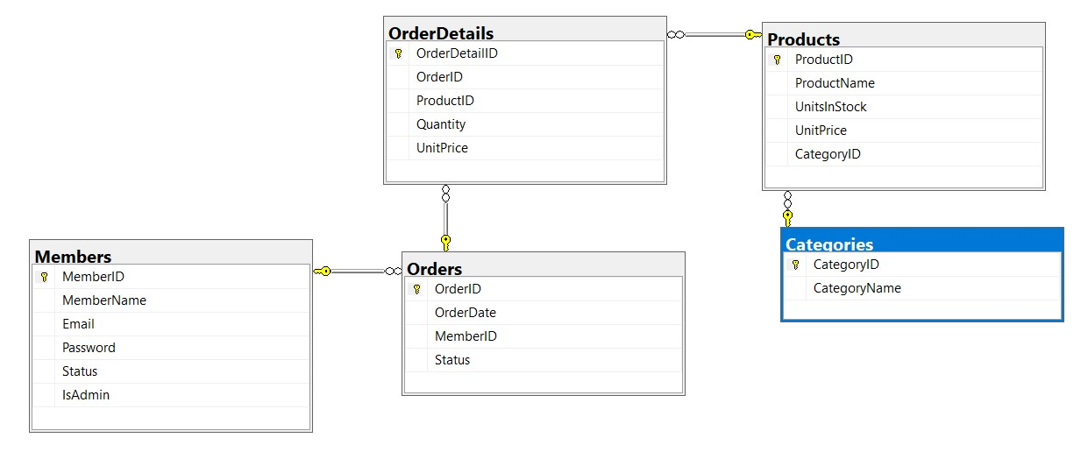

**Figure 1. Database Diagram**

The Database Diagram (Figure 1.) is a visual representation of how the information is arranged, stored and retrieved.

# System Architecture

## 3.1 Conceptual Diagram

Soft Copy Output:

* Bills
* Member profile
* Product information

Hard Copy Output:

* Bills

**INPUT**

**PROCESS**

**OUTPUT**

**BENEFITS**

1. Reduction of errors during the services.
2. Reduction of time consumed during the services.
3. Reduction of physical space allocated for the storage of forms.
4. Reduction of amount of expired goods.
5. Increase in customer correspondence due to a much smoother transaction.

**eStore**

**Figure 2. Conceptual Diagram**

**Feedback**

Data:

* Product information
* Order information
* Member information

Users:

* Administrators
* Store staffs (as Members)

Devices:

* Computer

The Conceptual Diagram (Figure 2.) is a visual representation of how the system will work by showing the relationship between the entities found under the Input, Process, Output and Benefit blocks.

INPUT block: The input block is segmented into 3 divisions, the Data, Users and Devices. Firstly, it indicates the data to be encoded and stored within the system which will then undergo processing. Next, the users are enumerated. They will be the ones who will utilize the system and provide the necessary information to be stored. Lastly, the media to which the users will use to gather and input data

PROCESS block: The process block refers to the proposed system which represents the entire process of the research.

OUTPUT block: The output block refers to the output or results produces during the entire process. These are categorized to Hard Copy and Soft Copy Output.

BENEFITS block. The benefits block refers to the listed benefits that the users of the entire system will gain. Thye users are Staffs.

## 3.2 Technical Information

OS: Windows 10

Language: C# with Entity Framework Core 5.0.11

Database: Microsoft SQL (SQL Servers)

Architecture pattern: three layers, consisting of Business Layer, Data Layer and Presentation Layer.

# Implementation

*Log in*

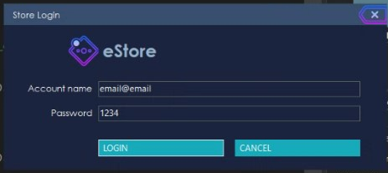*2 roles: Member and Admin*

## 4.1 Member Views

Product view: Add/Remove product to order + search/sort and Save order

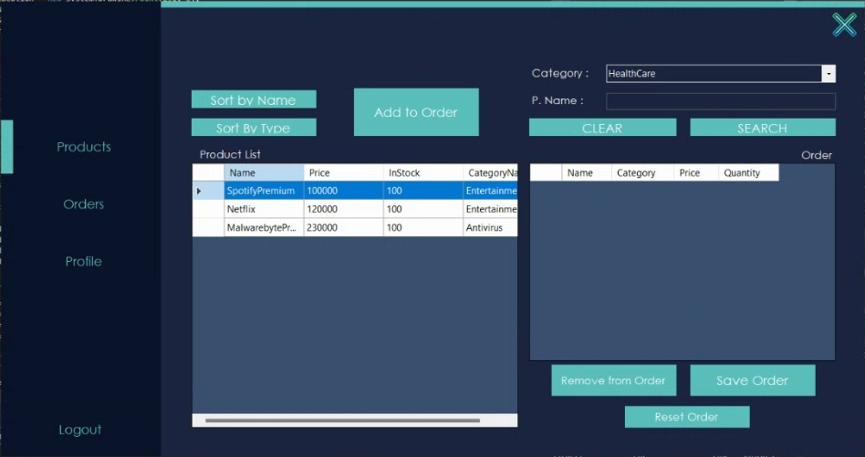

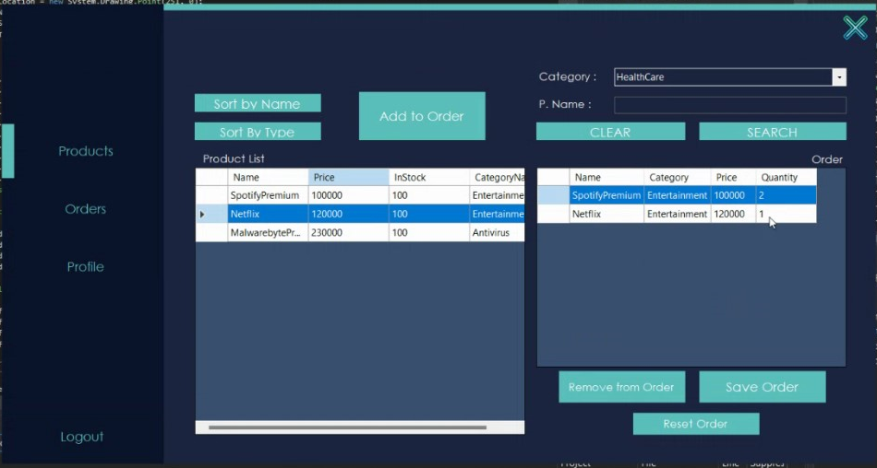

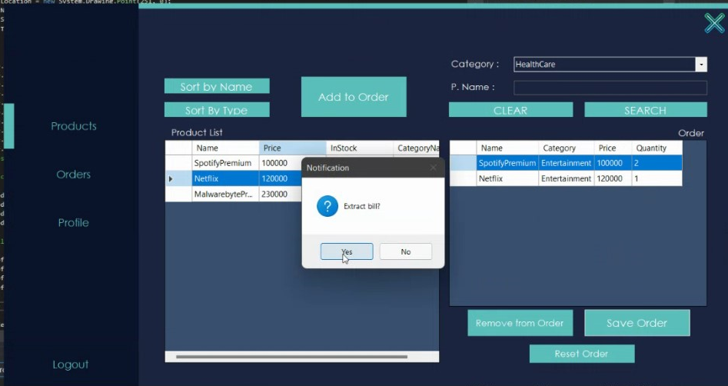

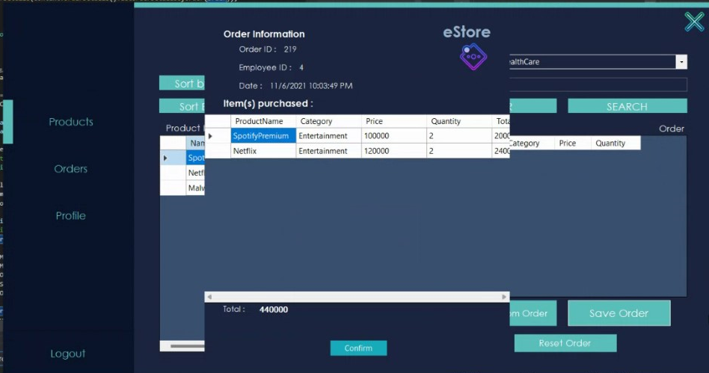

Orders view: View and See details

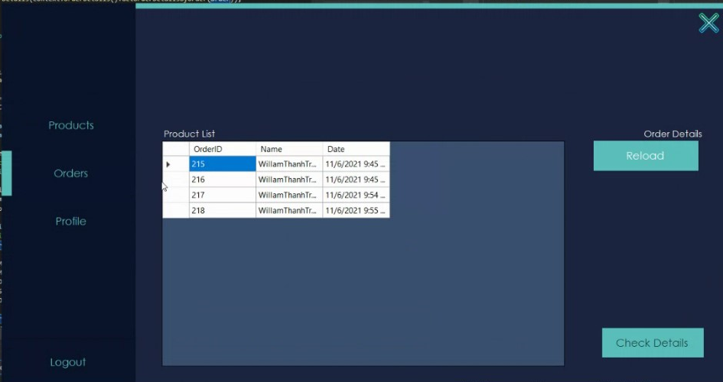

Profile view: View and Edit Member’s (logged in) details

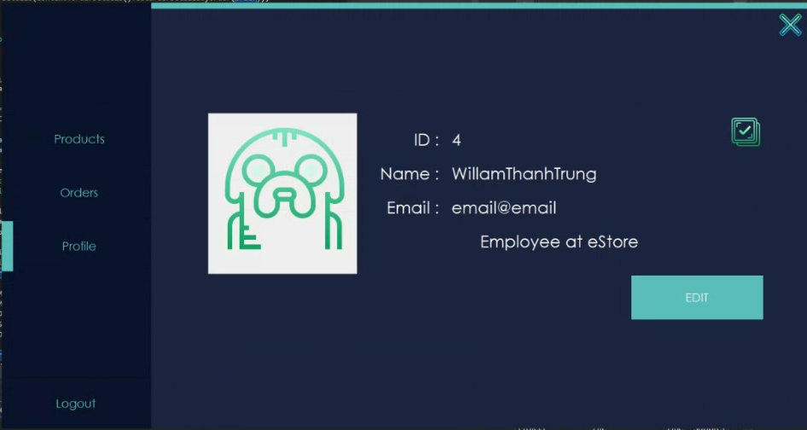

Edited

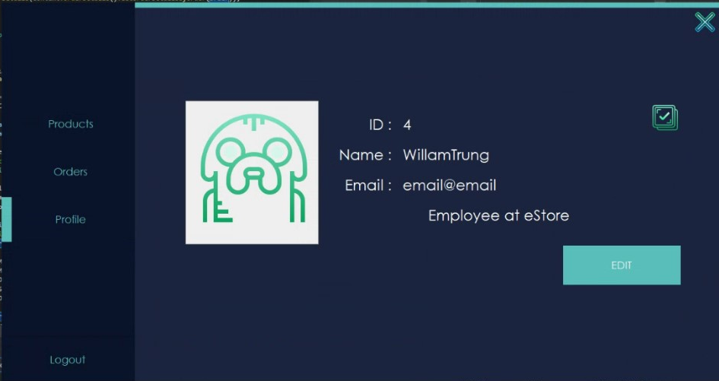

## 4.2 Admin Views

Category view: CRUD 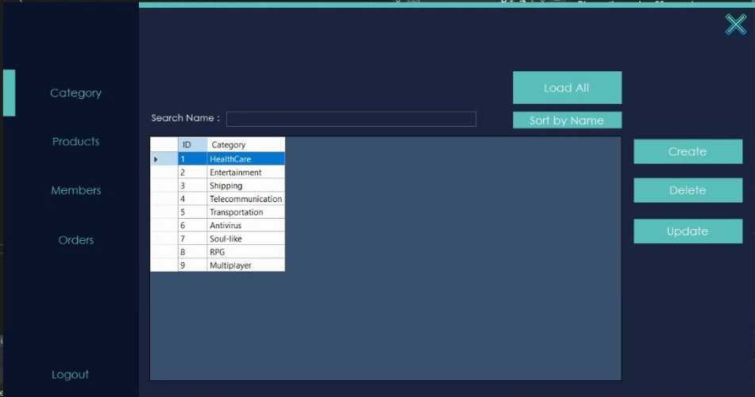

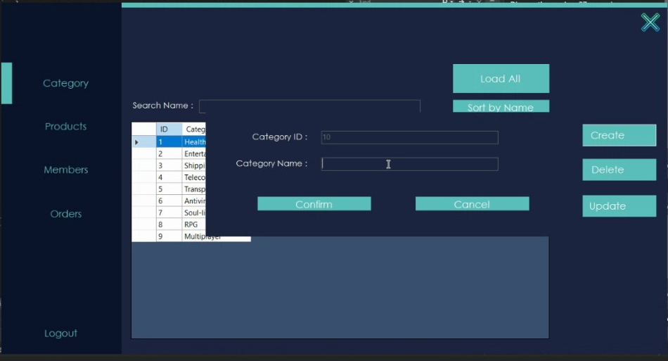

Product view: CRUD

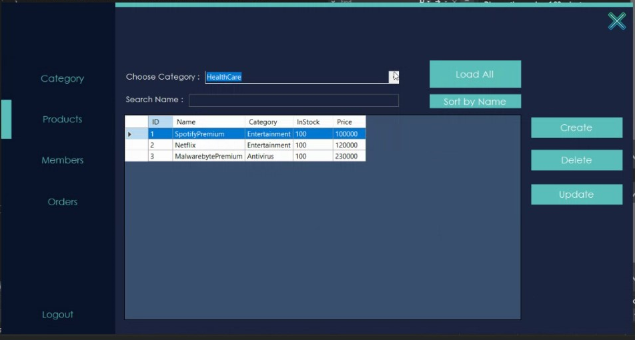

Member View: CRUD

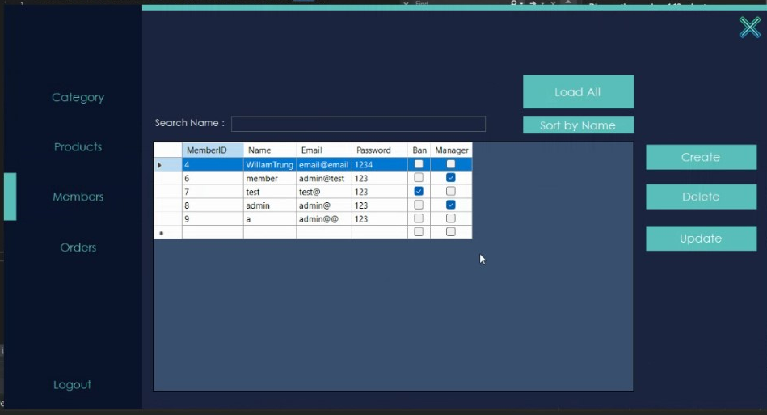

Order View: Only Read

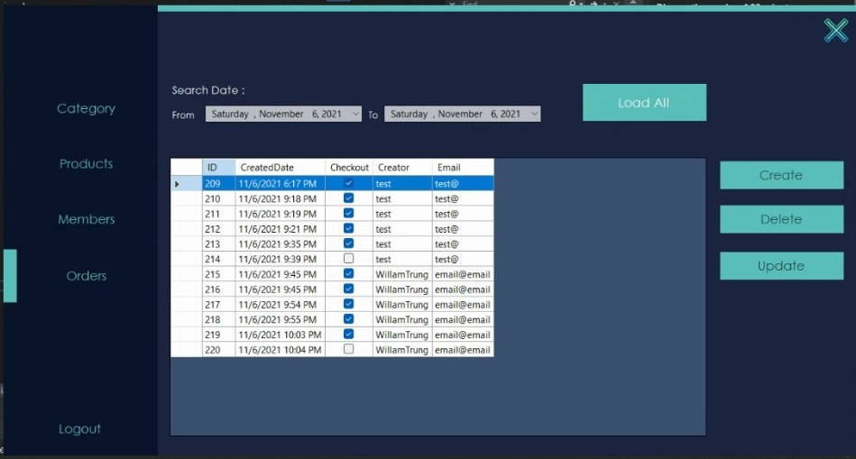

And some forms

Bill form (After saving Order)

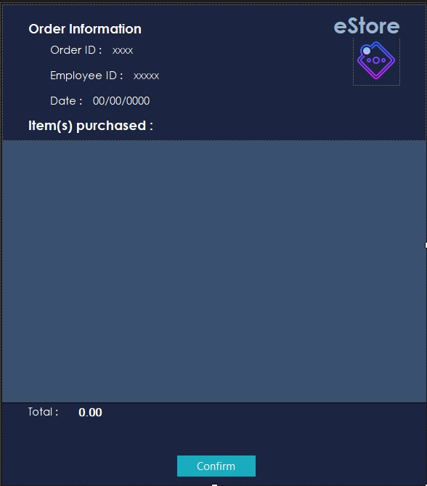

Category Details Form

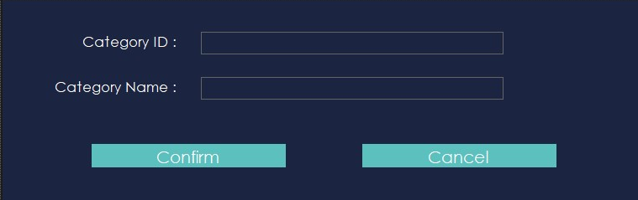

Member Details Form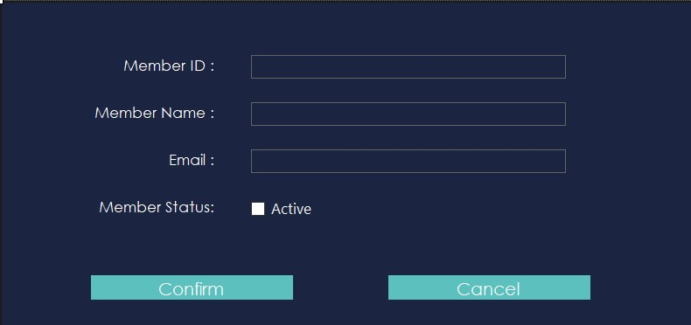

Order Details Form (unused)

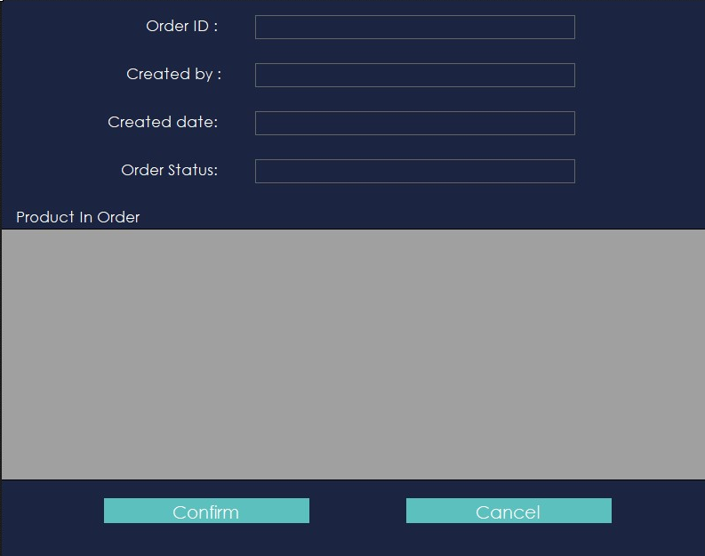

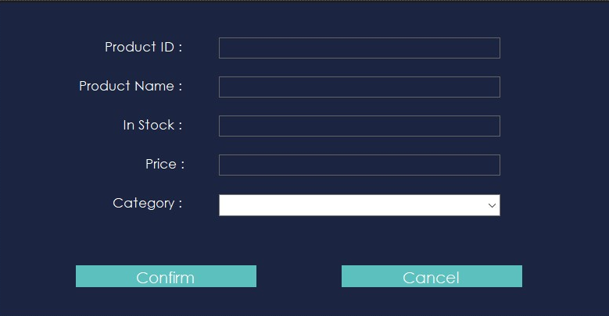

Product Details Form